Name: ___________________________________ Date: ______________________ Period: _______

Predicting Genotypes

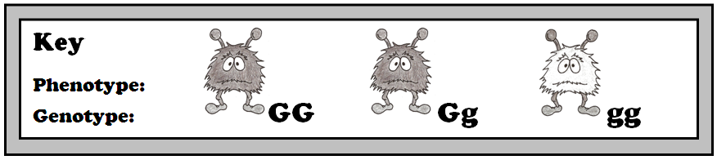

**Predict the genotypes of each set of parents based on the phenotypes of the parents and offspring. Assume that all possible phenotypes for the offspring are shown.**

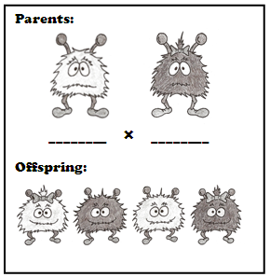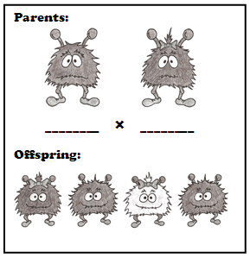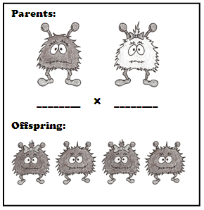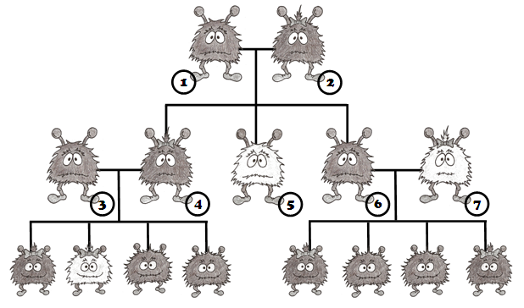

**Predict the most likely genotype of each numbered creature based on its phenotypes and the phenotypes of its offspring and parents.**

**1: ________ 5: ________**

**2: ________ 6: ________**

**3: ________ 7: ________**

**4: ________**

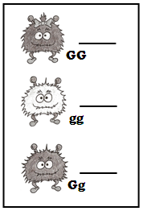

**Each child to the right belongs to a different set of parents below (1-3). Determine which child belongs to each set of parents.**

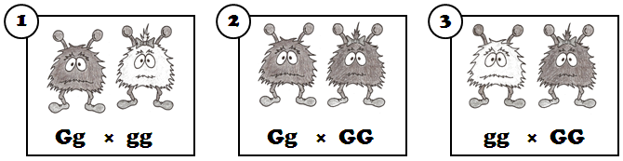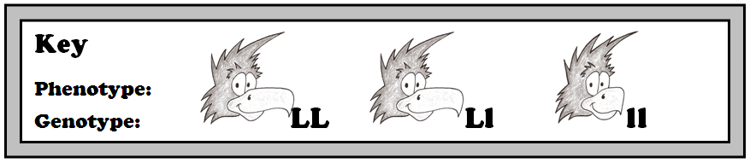

**Predict the genotypes of each set of parents based on the phenotypes of the parents and offspring. Assume that all possible phenotypes for the offspring are shown.**

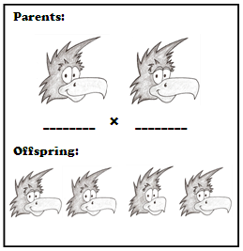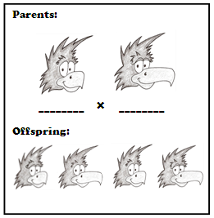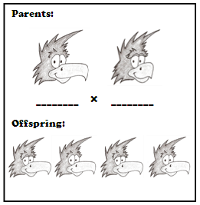

**Predict the most likely genotype of each numbered creature based on its phenotypes and the phenotypes of its offspring and parents.**

**1: ________ 5: ________**

**2: ________ 6: ________**

**3: ________ 7: ________**

**4: ________**

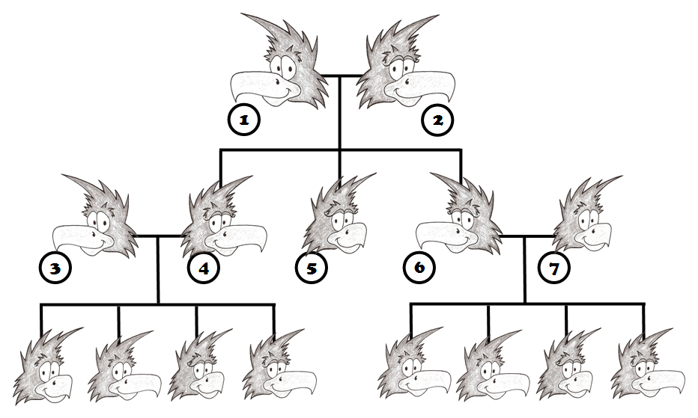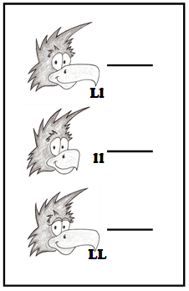

**Each child to the right belongs to a different set of parents below (1-3). Determine which child belongs to each set of parents.**

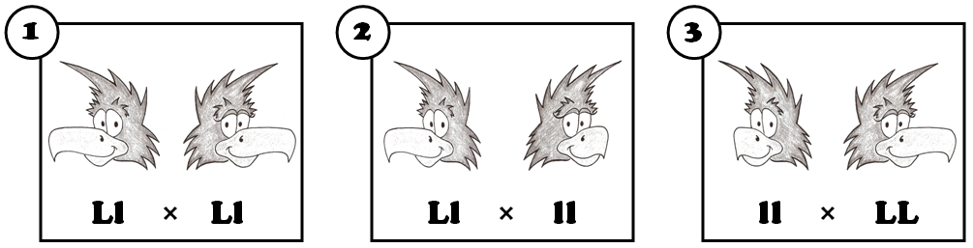

© Haney Science